Louis Ramírez, 80

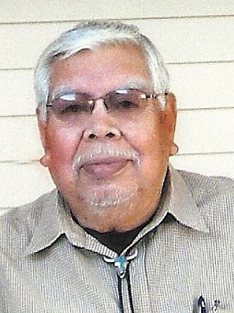
Visitation Schedule
Date: Wednesday, May 23, 2012
Time: 7:00 PM
Location: Nalley-Pickle & Welch Rosewood

Service Schedule
Date: Thursday, May 24, 2012
Time: 10:00 A.M.
Location: Holy Trinity Catholic Parish

Burial Location: Trinity Memorial Park - Big Spring

Died: Monday, May 21, 2012, in Big Spring, Texas

Louis C. Ramírez, 80, of Big Spring, died Monday, May 21, 2012, at his residence. A vigil service will be held at 7:00 PM, Wednesday, May 23, 2012, at the Nalley-Pickle & Welch Rosewood Chapel. Funeral services will be held at 10:00 AM, Thursday, May 24, 2012 at the Holy Trinity Catholic Parish. Interment will follow at Trinity Memorial Park.
He was born February 29, 1932, in Buda, Texas and was raised in Knott, Texas. He married Isabel Chavarría May 6, 1958 in Big Spring and she preceded him in death February 23, 2001.
Louis is a United States Army Veteran of the Korean War. His 40 years of dedication to R. E. Janes Gravel Co. culminated in his retirement as Site Manager. He was a member of Holy Trinity Catholic Parish and was an active and longstanding member of the Holy Trinity Catholic Choir.
His family will remember this outstanding man forever in their hearts as a hardworking, reliable man passionate about his family. A special thanks goes to Compass Hospice, for their excellent care during his most critical time of need.
Survivors include four daughters, Mary Bonilla and husband, Merardo of El Paso, Ruth Calderon and husband, Vicente, Louise Ramirez and Lisa Rodriguez and husband, Sam all of Big Spring; two sons, Felix Hilario of San Antonio and John Hilario and wife, Pilar of Carrollton; three sisters, Luz Luna, Simona Martinez and Martina Moron all of Coahoma; numerous grandchildren, great grandchildren and nieces and nephews.
He was also preceded in death by his parents, Carlos and Lorenza (Fabela) Ramirez; one son, Richard Hilario; one daughter, Josephine Calderon and one sister, Isabell Ramirez.

Arrangements under the direction of Nalley-Pickle & Welch Funeral Home & Crematory of Big Spring. Online condolences can be made at: www.npwelch.com

